Assignment-3

Que. 1) Create an html file with a submit button and style of the paragraph text through JavaScript code. a paragraph.

Task: Clicking on the button, the font, font size, and colour of the paragraph text will be changed.

Code:

<!DOCTYPE html>

<html>

    <head>

        <title>Question 1</title>

        <style>

            div{

                background-color: pink;

                width: 60%;

                margin: auto;

                margin-top: 50px;

            }

            button{

                margin-left: 50%;

                font-size: 20px;

            }

            p{

                padding: 15px;

                margin: auto;

                text-align: justify;

            }

        </style>

    </head>

    <body><div>

       <p id="changeText">It is rightly said that being disciplined is essential in life.

        When a person leads a disciplined life,they set an easy path to success.They will develop an approach to happiness and a beautiful future ahed.Being disciplined is the practice of having a scheduled daily routine which helps

        an individual to be punctual and hard-working.An individual is taught what being disciplined means from the time they are young. Even though discipline takes a lot of effort, the advantages of a disciplined life make it a worthwhile endeavour.

       </p> <br><br>

      <button onclick="changeStyle()">Submit</button>

    </div>

       <script>

            function changeStyle(){

                const para=document.getElementById('changeText');

                para.style.fontFamily='Arial,sans-serif';

                para.style.fontSize='30px';

                para.style.color='blue';

            }

       </script>

    </body>

</html>

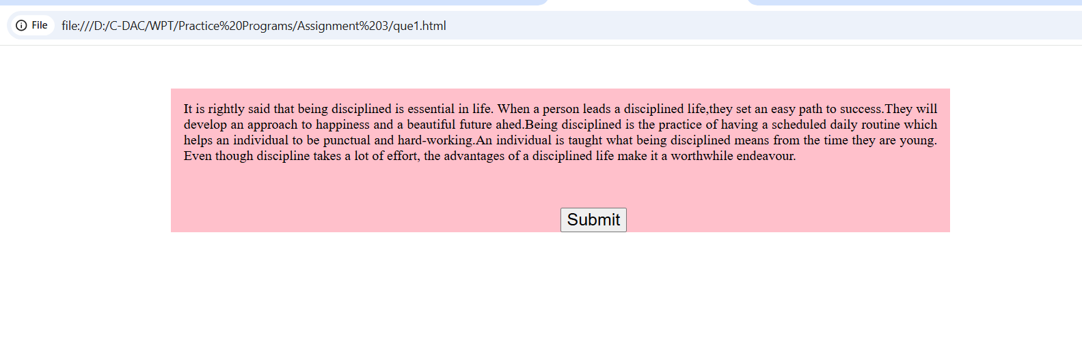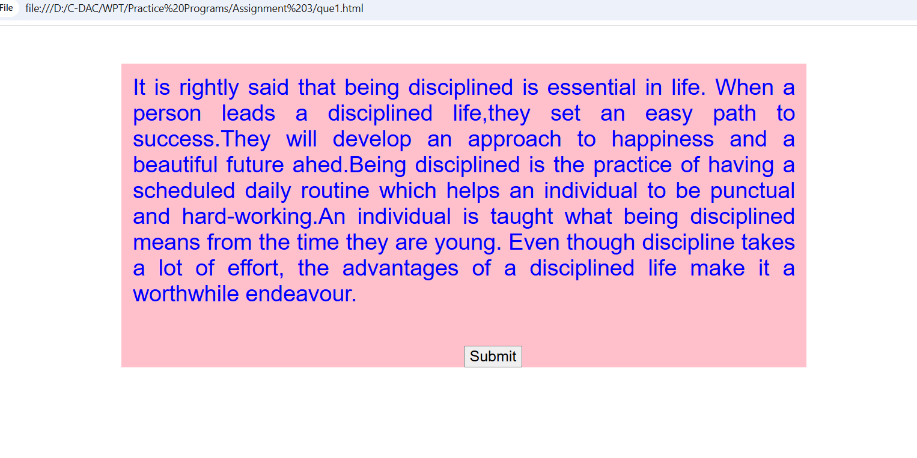

**Que. 2) Create a form with First name, last name, contact no., email id. Write a JavaScript function to get the values from that particular form. When a submit button is clicked, form values should be printed on the browser page.**

<!DOCTYPE html>

<html>

    <head>

        <title>Question 2</title>

    </head>

    <body>

        <form id="details">

           First Name: <input type="text" name="fname" id="fname">

           <br><br><br>

           Last Name: <input type="text" name="lname" id="lname">

           <br><br><br>

           Contact No: <input type="number" name="contact" id="contact">

           <br><br><br>

           Email: <input type="email" name="emailDisp" id="emailDisp">

           <button type="button" onclick="display()">Submit</button>

        </form>

        <h2>Form Details:</h2>

        <div id="result"></div>

        <script>

            function display(){

            const fname=document.getElementById('fname').value;

            const lname=document.getElementById('lname').value;

            const contact=document.getElementById('contact').value;

            const email=document.getElementById('emailDisp').value;

            const res=document.getElementById('result');

            res.innerHTML=`<p><strong>First Name:</strong>${fname}</p>

              <p><strong>Last Name:</strong> ${lname} </p>

               <p><strong>Contact No.:</strong>${contact}</p>

                <p><strong>Email ID:</strong> ${email}</p>`;

            }

        </script>

    </body>

</html>

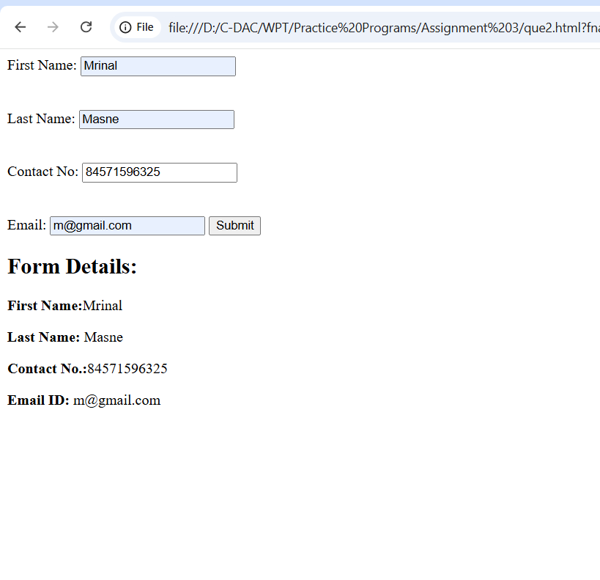

**Que 3) Write a javascript program to remove items from drop down-list .**

<!DOCTYPE html>

<html>

    <head>

        <title>

            Question 3

        </title>

    </head>

    <body>

        <form>

        <select id="removeItems">

            <option>One</option>

            <option>Two</option>

            <option>Three</option>

            <option>Four</option>

            <option>Five</option>

        </select>

        <br><br><br><br><br><br><br><br><br>

        <input type="button" value="Remove Items" onclick="removeSelect()">

    </form>

    <script>

        function removeSelect(){

        const x=document.getElementById('removeItems');

        x.remove(x.selectedIndex);

        }

    </script>

    </body>

</html>

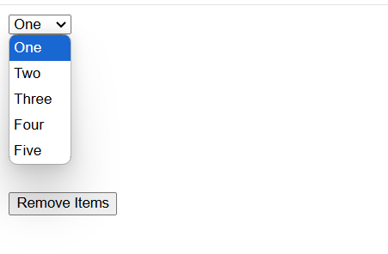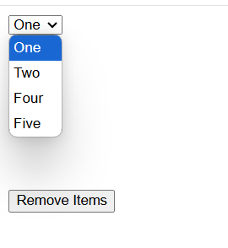

**Que. 4) Write a JavaScript program to highlight the bold words of the following paragraph, on mouse over a certain link**

<!DOCTYPE html>

<html>

    <head>

        <title>Question 4</title>

        <style>

            div{

                background-color: black;

                width: 50%;

                padding-top: 20px;

                height: 150px;

                margin-top: 50px;

                margin-left: 300px;

            }

            p{

                color:white;

                font-size: large;

            }

            b{

                color:black;

            }

            .highlight{

                color:green;

            }

        </style>

    </head>

    <body>

        <div>

       <p><a href="#" onmouseover="highlightBoldWords()" onmouseout="removeHighlight()">[On mouse over here bold words of the following paragraph will be highlighted</a></p>

       <p id="para"><b>We</b> have just started this section for the users(<b>beginner</b> to intermediate) who <b>want</b> to work

        with <b>various</b> JavaScript <b>problems</b> and write scripts online to <b>test</b> their JavaScript <b>skill.</b>

       </p>

    </div>

    <script>

           function highlightBoldWords() {

            const boldWords = document.querySelectorAll('#para b');

            boldWords.forEach(word => word.classList.add('highlight'));

        }

        function removeHighlight() {

            const boldWords = document.querySelectorAll('#para b');

            boldWords.forEach(word => word.classList.remove('highlight'));

        }

    </script>

    </body>

</html>

